Design brief to create two pop-up, portable units for Meet the Collection

Task
Create light-weight portable units to tour Royal Borough of Greenwich as part of a community focused project funded by Heritage Lottery Funding.

- I am a Museum Collection sees objects and artefacts from the Royal Borough’s collection, cared for by Royal Greenwich Heritage Trust, meet the communities of Greenwich.

- I am an Archive sees archival material, cared for by Royal Greenwich Heritage Trust, meet communities.

Project Outline

Meet the Collection will take two portable, immersive, pop-up exhibitions – ‘I am a museum’ and ‘I am an archive’ - facilitated by Royal Greenwich Heritage Trust staff and volunteers on a tour across the Royal Borough. Sharing local stories, through objects and artefacts from the diverse and extraordinary collections of the Royal Borough of Greenwich, this tour will see these pop-ups stop in a range of settings spread across Greenwich to meet local communities, whether in a library, town hall, park, church, shopping centre or heritage building.

Encouraging conversations about local history and showcasing the shear breadth of the Royal Borough’s collections, each portable display of intriguing and curious artefacts, will be designed to entice adults and families to open doors and drawers revealing treasures inside, whether Anglo Saxon bangle, Roman pottery sherd, Georgian grocer’s token, wax seal or 1950s theatre programme. Manned by staff and volunteers, each pop-up will offer visitors the chance to handle real objects, to discover hidden stories; and to create their own response to what they see and hear, through spoken and written word, art and craft. Please see image boards to inspire outcomes.

Specifics
- Must be very light-weight and portable: the units must be able to fit in a standard size car dismantled as this is the method of transportation for the tour across the borough. They must be built either with wheels attached, or with a trolley attachment (these should be factored into costings) additional components must equally be light weight but strong to sure they are suitable to use for the two-year duration.

- Any materials used in construction of cases or in areas that objects will be exposed to will need to be ODDY tested and approved. This is to prevent damage to the objects. There should also be a period allowed during construction for off-gassing of any coatings, finishes, or wood.

- Must be produced with durable, weatherproof materials as each unit will be transported to venues (both outside and inside) numerously over the two years and audiences will be encouraged to open drawers, doors and become immersed in the experience. They should both have an overhead cover as they will be used outdoors and possibly in the rain (this should cover both the unit and the staff member).
- Must be collapsible/ easy to dissemble and assemble and must fit in a regular sized car/ boot.
- Design must clearly indicate that the two units are part of a set: ‘I am a museum’ and ‘I am an archive’. Each must be branded with both Royal Greenwich Heritage Trust logo and Heritage Lottery Funding logo. Each must be attractive to both small children, families and adults – an accessible design finish that does not appeal more to one audience than another.

- Must be accessible for all audiences: small children, wheelchair users, adults, people with visual/ hearing impairment.

Project Fee
Up to £20,000 total (+VAT)
Suggested budget breakdown:
- £8,000 per unit (including wheels/ other method of moving unit around)
- £4,000 for snagging/ wear and tear

Contact
Helen Young, Community Engagement Producer, Royal Greenwich Heritage Trust
helen@rght.org.uk

More Information:
This project will be using a diverse selection of objects, artefacts, photographs, prints and other archival material from Royal Greenwich Heritage Trust. Research is currently underway to identify the artefacts; images of these should be used in the design for each portable museum/ archive display unit.

Deadline for proposal:
Proposals should include cost-breakdown, scaled illustrations, materials list, delivery of completed units to Royal Greenwich Heritage Trust, based at Charlton House, SE7 8RE.

Proposals should be returned to helen@rght.org.uk no later than Mon 1 July 5pm. The successful applicant will be appointed Mon 1 July. Allocated building time is 8 weeks, all works should be completed by Mon 2 September.

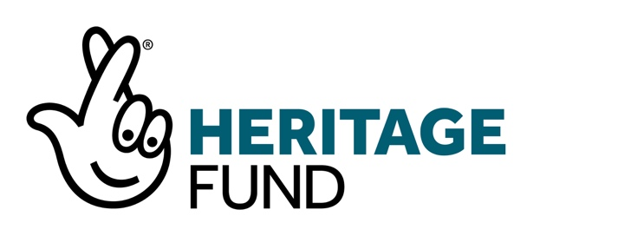

Project generously supported by National Lottery Heritage Fund

