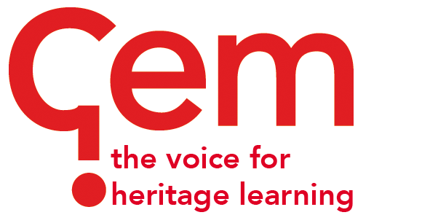

GEM Case Studies
The purpose of GEM Case Studies is to communicate the lessons learned from museums and heritage learning projects which have been designed in response to a particular challenge. It is published twice a year in March and October and distributed to GEM members as a PDF with about 24-32 pages printed in full colour.
The aim of Case Studies is to provide an opportunity for those working within learning in museums, heritage and cultural settings to share examples of best practice and challenges that we met along the way.
The focus of a GEM Case Study is not on “this is what I did” but rather “on reflection this is what I would have done”. The more you analyse what you have done, the more useful your case study is likely to be to others.
October 2020 – "Remote learning in museums, heritage and cultural settings"

The coronavirus pandemic forced museums, heritage and cultural settings across the globe to close their doors and think differently about learning. In this Case Studies edition, we aim to feature the innovative work of learning professionals who have explored different models of remote learning, both digital and physical, especially during lockdown.
We are keen to hear from museums, galleries and heritage sites that have pivoted to offer learning opportunities to schools, communities, early years, older adults and families during enforced separation due to Covid-19.
Deadlines:
- Please send your initial case studies suggestions to devon@gem.org.uk using the template below by 14 August 2020.
- Contributors will be notified by 21 August 2020 as to whether or not they are invited to submit a case study.
- Contributors will then be asked to submit the final 750-1,000-word case study by Friday, September 18, 2020.

Suggested title:

Author(s):

Summary:
(Brief outline of the project)

Areas of work:

