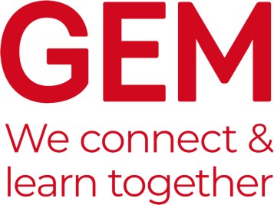

GEM Case Studies
The purpose of GEM Case Studies is to communicate the lessons learned from museums and heritage learning projects which have been designed in response to a particular challenge. It is published twice a year in Spring and Autumn and distributed to GEM members as a PDF with about 24-32 pages in full colour.
The aim of Case Studies is to provide an opportunity for those working within learning in museums, heritage and cultural settings to share examples of best practice and challenges that we met along the way.
The focus of a GEM Case Study is not on “this is what I did” but rather “on reflection this is what I would have done”. The more you analyse what you have done, the more useful your case study is likely to be to others.
Spring 2021 Vol. 27 – "Creating Community Partnerships"
Learning within museums, heritage and cultural settings has gone beyond programming for communities to programming with communities; from start to finish. The events of 2020 including the Covid-19 pandemic and multiple lockdowns have illustrated the importance of community and local connections.
As communities shift, grow, change and evolve, so must museums, heritage and cultural institutions and focus on developing learning programmes that reflect changing demographics and involve under-represented groups. This edition will include multi-generational examples of community engagement from early years to older people, drawing inspiration from the GEM-supported Museums Association Manifesto for Learning and Engagement.
Deadlines:
- Please send your initial case studies suggestions to devon@gem.org.uk using the template below by Friday, 5 February 2021.
- Contributors will be notified by Friday, 12 February 2021 as to whether or not they are invited to submit a case study.
- Contributors will then be asked to submit the final 750-1,000-word case study by Friday, 5 March 2021.

Suggested title:

Author(s):

Summary:
(Brief outline of the project)

Areas of work:

