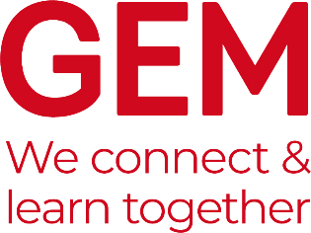

GEM Case Studies
The purpose of GEM Case Studies is to communicate the lessons learned from museums and heritage learning projects which have been designed in response to a particular challenge. It is published twice a year in the Spring and Autumn/Winter and distributed to GEM members as a PDF with about 24-32 pages printed in full colour.
The aim of Case Studies is to provide an opportunity for those working within learning in museums, heritage and cultural settings to share examples of best practice and challenges that we met along the way.
The focus of a GEM Case Study is not on “this is what I did” but rather “on reflection this is what I would have done”. The more you analyse what you have done, the more useful your case study is likely to be to others.
November/December 2021 – “Young People”

Young people have been heavily affected by the COVID-19 pandemic, including having both their formal and informal learning interrupted. As we consider the future of learning within museums, heritage and cultural settings it is essential to explore how we include young people in what we do and how we engage them in a ‘post-COVID’ world. Meeting young people where they are and creating a space for them to learn can challenge our practices and provoke us to re-examine what we consider to be ‘best practice’.
This edition will seek to highlight examples of successful learning and engagement opportunities for young people in museums, heritage sites and cultural settings, as well as creating space to reflect on what we can do better.
We are keen to hear from museums, galleries and heritage sites that have engaged with young people across the board, including; formal and informal learning, placements, qualifications, and investing in co-production with young people.
Deadlines:
- Please send your initial case studies suggestions to jessica@gem.org.uk using the template below by 17 September 2021
- Contributors will be notified by 24 September 2021 as to whether or not they are invited to submit a case study.
- Contributors will then be asked to submit the final 750-1,000-word case study by Monday, October 11, 2021.

Suggested title:

Author(s):

Summary:
(Brief outline of the project)

Areas of work:

