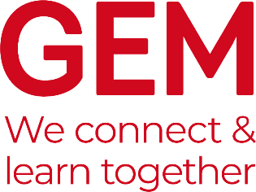

GEM Case Studies
The purpose of GEM Case Studies is to communicate the lessons learned from museums and heritage learning projects which have been designed in response to a particular challenge. It is published twice a year in the Spring/Summer and Autumn/Winter and distributed to GEM members as a PDF with about 24-32 pages printed in full colour.
The aim of Case Studies is to provide an opportunity for those working within learning in museums, heritage and cultural settings to share examples of best practice and challenges that we met along the way.
The focus of a GEM Case Study is not on “this is what I did” but rather “on reflection this is what I would have done”. The more you analyse what you have done, the more useful your case study is likely to be to others.
Spring/Summer 2022 – “Health and Wellbeing”
Engagement with museums, heritage sites and other arts and culture organisations has been linked to improved health and wellbeing outcomes for visitors. Studies commissioned by the DCMS, Heritage Alliance, Arts Council and other sector organisations have particularly highlighted benefits for children’s social development, memory function in older age, and wellbeing improvements in adults. Art Fund’s Wellbeing report reveals that people who visit museums and galleries report a greater sense of satisfaction with their lives than those who have never visited.
This issue will seek to highlight examples of sustainable learning and engagement opportunities within museums, heritage sites and cultural settings that seek to improve health and wellbeing for visitors. As we step out into a world permanently changed by a global health crisis, it is crucial that our sector rises to the challenge of helping to transform people’s health, wellbeing and outcomes for the better. Featured Case Studies will provide inspiration, motivation and key learning takeaways for other sector organisations seeking to explore this opportunity, as well as creating space to reflect on what we can do better.
We thank the Culture, Health and Wellbeing Alliance (CHWA) for their input and support for this issue of the GEM Case Studies.
We are keen to hear from museums, galleries and heritage sites that have taken a strategic approach to health and wellbeing, considering positive wellbeing impact for all visitors.
Deadlines:
- Please send your initial case studies suggestions to jessica@gem.org.uk using the template below by Friday, 4 March 2022
- Contributors will be notified by 11 March 2022 as to whether or not they are invited to submit a case study.
- Contributors will then be asked to submit the final 750-1,000-word case study by Monday, 7 April 2022.

Suggested title:

Author(s):

Summary:
(Brief outline of the project)

Areas of work:

