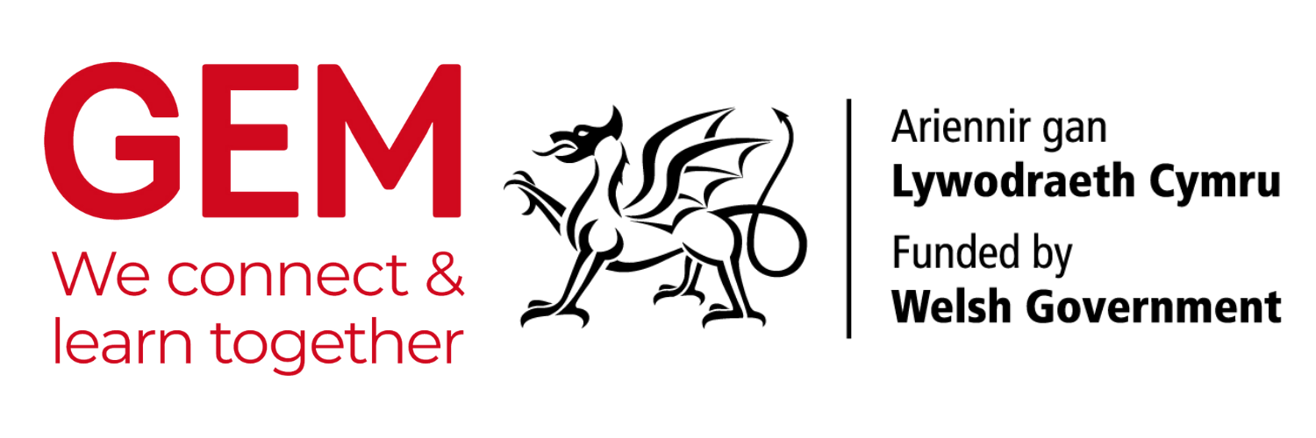

SUPPORTING SCHOOLS DELIVER ON THE NEW CURRICULUM FOR WALES
including the teaching of Black, Asian and minority ethnic histories

GUIDANCE NOTES
These guidance notes form part of a training package that has been developed by GEM to support the delivery of a 15-minute InSeT (In-Service Training) presentation. The presentation is designed to be delivered to teachers (either online or in person) by cultural heritage staff in Wales to:
- Inform on how school visits to your sites can help teachers deliver the new curriculum in Wales.
- Advise on how your collections can support learning about Black, Asian and minority ethnic histories.
- Encourage schools to visit museums, local study libraries and archives.
- Support you deliver against the Welsh Government’s Anti-Racist Wales Action Plan (ARWAP).
- Deepen relationships between the cultural sector and schools in Wales.
THE TRAINING PACKAGE
The package consists of:
- Guidance notes (this document).
- A PowerPoint presentation.
- Presenter notes to support the delivery of the presentation.
BACKGROUND NOTES FOR PRESENTERS
- The curriculum for schools in Wales has changed. There is now a requirement for learning to be more flexible, encouraging teachers to expand learning opportunities outside of the classroom.
- The concept of cynefin (loosely translated as locality or the place around you) underpins the entire curriculum, meaning that learning across all subjects must, at some level, include local elements. The term cynefin can be interpreted to include the area around a school to Wales’s influence on the world or global impact on Wales.
- Essential for this training package is that Black, Asian and minority ethnic histories are mandatory in the new curriculum.
- Teachers are actively seeking learning material for cynefin and Black, Asian and minority ethnic histories. Museums, local study libraries and archives are ideally placed to deliver this. This training session will help you reach out schools to promote this service.
THE NEW CURRICULUM FOR WALES
Key points for you to consider when working with schools:
- The curriculum is based on six areas of learning (covered individually in the presentation).
- The new curriculum is not proscriptive, with few mandatory subjects. It is expected that Black, Asian and minority ethnic histories are embedded across all areas of learning. This provides staff at museums, local study libraries and archives with an ideal opportunity to support schools in delivering the curriculum, enrich the learning of schoolchildren, and sustain long-lasting relationships with their communities.
- The overarching expectation of the new curriculum is to nurture ethical and informed citizens of the world.
DELIVERY
- The training session is designed to be short. It can be delivered at school meetings, teacher training days, or any engagement event your site is offering. It should take no more than 15 minutes to deliver. It can be presented online or in person.
HOW TO CONTACT SCHOOLS
- GEM has an excellent range of resources to help you reach out to schools HERE.
- The Welsh Government has a list of all schools in Wales HERE.
- Local authorities will have an online list of each school it is responsible for.
SHARED JOURNEY
- The requirements of the curriculum and the ARWAP are new for most of us. Speaking openly with teachers will help establish strong relationships with your teachers and help you share your collections to new audiences.
DELIVERING THE PRESENTATION
Before:
- For confident delivery, familiarise yourself with the notes for each slide.
- Personalise your training session by adding objects or information from your site where indicated in the PowerPoint presentation.
- Familiarise yourself with the principals of the new Curriculum for Wales and the Anti-Racist Wales Action Plan to support your engagement with teachers.
TIPS
- This presentation is designed to be delivered in around 15 minutes, and so there is little time for the usual types of introduction. To make everyone feel comfortable from the beginning, it would help if all present could briefly give their names.
- If presenting online, request that participants turn mics off but leave their cameras on.
ESSENTIAL READING
- Curriculum for Wales HERE
- Anti-Racist Wales Action Plan HERE

InSeT presentation pack produced by Marian Gwyn www.mariangwyn.com
May 2023

