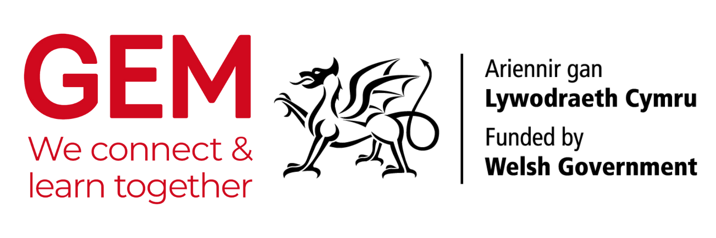
GEM InSeT training package for museum, local studies libraries and archive staff
SUPPORTING SCHOOLS DELIVER ON THE NEW CURRICULUM FOR WALES
including the teaching of Black, Asian and minority ethnic histories

PRESENTER NOTES
See Guidance Notes for background information on the presentation.
Keep to time – 15 minutes max.
Emphasise that each museum, local studies library and archive is different, and each will have its own unique collections.
Images in the presentation are for indicative purposes only. They illustrate how items similar to what MLAs might have could be used to explore areas of the curriculum, including cynefin and minority ethnic histories.
THE PRESENTATION
Slide | Content and context | Image/s
1 | Cover page  Give your name and where you’re based.  Ask everyone to introduce themselves briefly.  Outline the session - you want to tell them why MLAs in Wales are useful places to support their teaching of the new curriculum. | A selection of items that illustrate the sorts of things museums, local study libraries and archives might have. Even looking briefly at these we can see how they can support learning areas such as cynefin and minority histories. Royal Welsh Fusiliers (goat image) served across the British Empire. The Cenhadwr Americanaidd (The Welsh Missionary) was published in Welsh in America for decades and discussed issues such as slavery.
2 | Opportunities and challenges  We know this is a challenging time for teachers – They’re busy developing new learning programmes. We can help. | Royal Welch Fusiliers regimental goat. Who is in the photo, where did the Fusiliers serve – use this information to support research into minority ethnic histories.  Pamphlet on John Ystumllyn, an 18th century gardener, who grew up by Pwllheli. How did he get there? How was he treated? Evidence of diversity in Wales over centuries.
3 | Why come to us  We can offer unique experiences that are unavailable in the classroom. | School visit to old kitchen. What technology were they using, where did the food come from, how did they manage the accounts? Where did the spices come from? What evidence of global trading and empire?  Old books – There is nothing quite like the experience of handling an old object (or looking at one, if they can’t handle it)
4 | Who we are  A chance for you to provide a brief overview of the variety of sites available for them to visit. Few schools in Wales are far from at least one of them.  Museums We have over 100 museums in Wales. 7 are run by National Museum Wales, while the rest are run by local authorities, universities, charities, independent groups, voluntary bodies. This means that when you contact a museum, you could be speaking to someone highly trained in heritage management or a volunteer who happens to have a passion for whatever the museum has. A museum typically shows only a small percentage of what it has to the public. The rest is behind the scenes in stores – ask us about these.  Local studies libraries These can be part of a general library. You won’t find here the latest novels, but you will find books on specialist local subjects, transactions of local history societies, books or pamphlets written by key local figures, and photographs.  Study libraries typically don’t have galleries or displays for visitors to explore, like in a museum.  Archives These can store anything from official company documents to the smallest detail about a community. Archives in Wales are full of personal documents, photographs, and even oral histories of local people. They can also have documents that connect Wales to the world, such as West Indies plantation records, letters written by someone in the East India Company, records of Welsh soldiers on campaign around the world, or documents recording diversity in Wales over centuries.
5 | Why come to us  We can provide evidence from original sources to support your research. | Exploring original documents can promote critical thinking in young minds. Card – One child’s response to reading a challenging document about slavery.
6. | Areas of Learning and Experience – Language, literacy and communication  All our collections can excite curious minds. Learners can discuss what they find, research further and ask questions | Learner exploring an exhibition on slavery – exhibition set up by school following visit to research original documents connected to slave trade.  Ivory fan – made from tusk of African elephant. Many ivory objects can be found in our collections. How did the ivory get there? What does it say about international trade and the British Empire at the time? What does this tell us about conservation now?
7 | Areas of Learning and Experience – Humanities  MLAs have so many items that can support this AoLE. Ask teachers to discuss their themes with you. | See above for school visit to old kitchen  Map of Cardiff by John Speed. Maps are gateways to how people of the past saw themselves and where they lived or wanted to go to.
8 | Areas of Learning and Experience – Science and technology  Searching our catalogues will reveal a wealth of information to support this AoLE. Some of us have old scientific instruments, letters or journals from travellers or explorers, or ask us about how we care for our unique objects. | Exploring textiles – Pupils learning about how touching delicate fabrics damages them. The fabric has silk in it – where did the silk come from? How did it get to Wales?  Sugar nippers – Technological items, but can also be used to explore sugar, transatlantic slavery and health
9 | Areas of Learning and Experience – Mathematics and numeracy  Not only do we have old account books and ledgers, but handling the huge amount of information will teach them how to interpret and record historical data | Old record books provide great experience in managing data. What are our accounts recording? Anything from other countries? What are they bringing in?
10 | Areas of Learning and Experience – Health and well-being  Leaving the classroom will be a valuable experience. Additionally, our collections have evidence of how others thought about their environments and what they did about it. New thinking will inspire confidence and self-reliance | It’s great to visit somewhere new.
11 | Areas of Learning and Experience – Expressive arts  Endless possibilities here. Ask teachers to work with you on short visits or on longer projects. Some of us have the space for you to produce creative work beyond the classroom. | Endless possibilities for creative arts. The children on the left are responding to researching the slave trade. They set up an exhibition of the work they produced as a consequence of their learning.
12 | Black, Asian and minority ethnic histories  We are only now beginning to understand how many of our collections connect to empire, Atlantic slavery and diversity. Encourage teachers to work with you so that you can provide them with the evidence they need. Remind them that this subject is still relevant, even if they’re in a rural area – we have things that connect Wales to the world no matter where you are.  Minority histories are not just about empire and slavery – we have so much more. We’re only just beginning the process of finding them so work with us on this. | Young girl examining a cabinet displaying an 18th century tea service. She is exploring how the British ceramics industry expanded dramatically as sugar produced by enslaved workers was imported into the country.
13 | Insert your own images here from your site.
14 | Making this work  This is new for both of us – we need to be honest about where we are and what services we can provide. Encourage teachers to speak to you about what they’re doing (after the meeting or on another day). Cultural and age sensitivity is critical when exploring some of our objects and documents. Talk to us about how we do this together.
15 | Practicalities  Some teachers may not know your site. It is a significant responsibility taking children and young people out of school, and they want to get it right.
16 | The way forward  What you want out of this session – you want them to contact you. You want to hear about what themes they’re exploring, and you want to show them that you know about the purpose of the new curriculum
17 | Last slide  Use it to sum everything up. Q&A if there’s time. Remind them to contact MLAs directly to start an open dialogue on moving forward with this.
18 | Image credits  There if people want to know anything about the images and to show due diligence.

