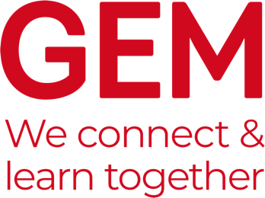

GEM Case Studies
The purpose of GEM Case Studies is to communicate the lessons learned from museums and heritage learning projects which have been designed in response to a particular challenge. It is published twice a year in March and October and distributed to GEM members as a PDF with about 24-32 pages printed in full colour.
The aim of Case Studies is to provide an opportunity for those working within learning in museums, heritage and cultural settings to share examples of best practice and challenges that we met along the way.
The focus of a GEM Case Study is not on “this is what I did” but rather “on reflection this is what I would have done”. The more you analyse what you have done, the more useful your case study is likely to be to others.
Spring 2024 – "Reimagining Engagement "

The next edition of the Case Studies will be focused on Reimagining Engagement and will feature the work of the Art Fund Reimagine Grant holders. If you have previously received this grant and would like to share the project you and your team developed using the funding, submit your Case Study suggestion form to Katya by 22 January 2024.
Deadlines:
- Please send your initial case studies suggestions to devon@gem.org.uk using the template below by Monday 22 January 2024.

Suggested title:

Author(s) & organisation:

Summary:
(Brief outline of the project)

Areas of work:

